Nominations for the 2018 Queensland Tourism Awards are open

There have been some exciting new tourism products entering the market over the past year and with a number of high-quality operators in our association, we want to see these businesses be recognised as the State’s best.
The nomination process is quick, taking just 5 minutes and once your nomination is entered work can begin on your submission. 2017 saw the introduction to the streamlined online submission process which will be used on 2018 with some functionality improvement applied late last year. To nominate please click here
If you have any questions regarding the awards, please feel free to contact the event owner, the Queensland Tourism Industry Council (QTIC) via awards@qtic.com.au or call 07 3236 1445.

#QTA18 Key Dates
- Nominations close 31 May 2018
- Submissions due 21 August 2018 (entrants have close to 3 months to work on submissions!)
- #QTA18 Gala Awards Ceremony is on Friday 16 November at The Star Gold Coast
#QTA18 Quick Links
- Queensland Tourism Awards flyer
- Queensland Tourism Awards categories
- Accreditation and the Queensland Tourism Awards
All QTA entrants are required to be certified or accredited through a recognised Accreditation program, with the exception of a handful of categories. For further advice on the most appropriate Accreditation program for your business, please contact QTIC via accreditation@qtic.com.au.
#QTA18 Entrant Support
QTA Regional Workshops:
QTIC will be heading into the region to provide entrants with some workshops. Click here to download the flyer with all relevant regions.
Regions:
Whitsundays - Friday 27 April
Gold Coast - Tuesday 1 May
Fraser Coast - Friday 4 May
Brisbane - Tuesday 15 May
Rockhampton - Wednesday 16 May
Townsville - Wednesday 30 May
Cairns - Thursday 31 May
Sunshine Coast - Wednesday 13 June
WEBINAR - end of June
First time entrant webinar - Recording
The webinar will be tailored to suit both first time entrants and will provide an understanding of the Awards submission process including the introduction of the new online submission portal as well as other important information and tips. The webinar is beneficial for previous award entrants also, providing an opportunity to refresh your memory and pick up on some very helpful tips. Presenter: Linda Tillman, Managing Director of the Tilma Group.
Click here to view
Online resources:
- How to Write an Award Winning Submission Guide – access here
- The Online Portal User guide – access here
- Judges Tips – access here

Get accredited in time for the 2018 Queensland Tourism Awards
If entering your business into the Queensland Tourism Awards is a goal in 2018 now is the time to ensure you are eligible to apply by obtaining accreditation/certification. QTICs Accreditation Manager Gemma Haskings is available to guide you through this process and discuss the various options that best suits your business. QTIC will also be offering a 10% discount on ATAP accreditation if you register before 1 June 2017. For further information contact Gemma via 07 3236 1445, email accreditation@qtic.com.au or click here for further information on the various programs accepted by the Queensland Tourism Awards.
The 2018 Queensland Tourism Awards are proudly brought to you by:
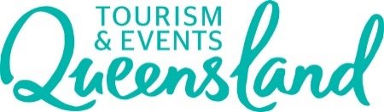
in partnership with
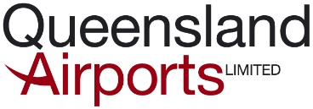

and
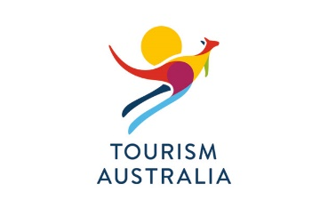
supporting partner

Follow the Queensland Tourism Awards on Facebook!

About QTIC

Queensland Tourism Industry Council (QTIC) is the peak industry body for tourism in Queensland, “The Voice of Tourism”. QTIC is a private sector, membership-based organisation which, since 2001, has worked to influence and shape the state’s tourism business environment that directly contributes $23 billion to the Queensland’s economy and employs more than 241,000 Queenslanders. READ MORE

